Cybersecurity Fundamentals & SOC operations
  - TechBiz Academy | SOC Analyst Internship | Week 1 – Task 1

01 – CIA Triad
CIA Triad are the 3 core pillars of cybersecurity; Confidentiality means the data/information is only accessible to the ones who are authorized to access it. Integrity means the data is not altered and is accurate, for example when downloading an ISO file, I would check the checksum of the ISO to verify the file I downloaded and the file on the official website is the same to ensure its integrity. Availability, data/information should be available to the authorized personnel when it is necessary. Collectively these principles are in focus when creating a security plan or protecting data and information.

02 – Threat, Vulnerability and Risk
- Threats are the actors who try to use the vulnerability/ weakness in a system to exploit them.
- Vulnerability is the weakness in the system like an unpatched software or unsupported system with EOL which the threats might be able to exploit.
- Risk is the likelihood or the impact of a threat exploiting a vulnerability.
For example: A website which has transfers username and password in clear text could be vulnerability, an attacker capturing packets of the network could be a threat and the attacker using the clear text password to login to the system and exporting the records could be a risk.

03 – Definition and Purpose of SOC
Security Operation Center (SOC) is a dedicated team consisting of SOC analysts, Security Engineers, Incident Responders and Threat hunters who collectively work together in improving the cybersecurity posture of a company by preventing, detecting, and responding to threats.
The purpose of a SOC is to prevent, react and improve security of company with Threat Detection by continuous monitoring of organization’s entire environment with tools like SIEM, SOAR, and XDR. Incident response by quickly taking action to limit damage of the attack and ensure the apps tools and processes are compliant with regulations and standards.
Role | Responsibilities
L1 Analyst | Monitor Alerts, perform triage, collect evidence, prioritize and escalate activities.
L2 Analyst | Investigate escalated alerts, correlate logs, assess impact, coordinate containment.
L3 Analyst | Investigate complex threats perform advanced analysis, support difficult escalations.

04 – Red team and Blue team
Red team | Blue Team
Offensive Security | Defensive security
Simulates authorized attacks | Detects and responds to attacks
Tests security controls | Operates and improves security controls
Identifies weakness in defense | Investigates suspicious activity
Reports findings and recommendations | Documents incidents and improves defense.

05 – Practical Learning and Evidence
TryHackMe room completion
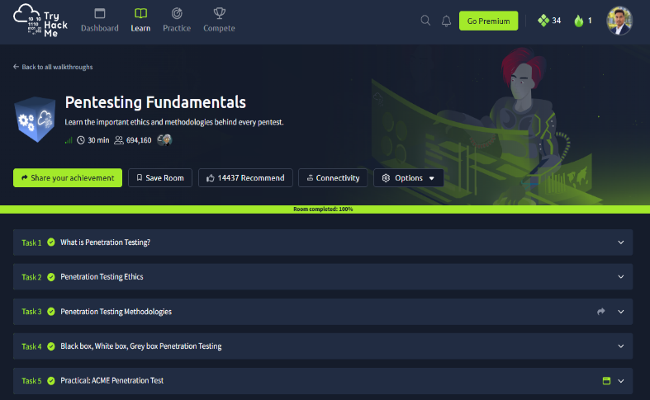 | 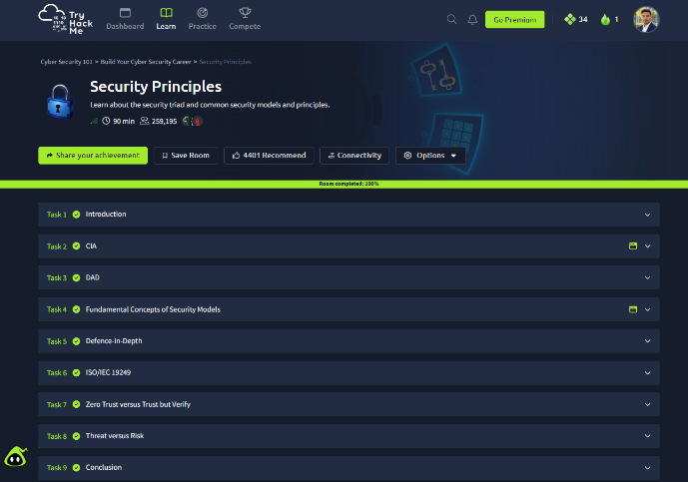
Notes link:
https://app.notion.com/p/Week-1-Task-1-notes-414f4771e2948045ba45ea51ac6bb69c?source=copy_link

